PROJECT REPORT

TITLE:UNLOCKING INSIGHTS INTO THE GLOBAL AIR TRANSPORTATION NETWORK

1.INTRODUCTION

1.1 OVERVIEW

Unlocking insights into the global air transportation network is a multifaceted process that involves the collection, analysis, and interpretation of data and information related to the worldwide aviation industry. These insights are crucial for airlines, airports, government agencies, policymakers, and various stakeholders to make informed decisions, enhance operational efficiency, and address challenges. Gathering a wide range of data, including flight schedules, passenger information, cargo statistics, weather data, and historical performance records. Compiling data from multiple sources, both public and proprietary, to create a comprehensive dataset. These insights enable stakeholders to optimize operations, improve safety and security, and address sustainability concerns within the dynamic and interconnected world of air travel.

1.2. PURPOSE

1. Connectivity: Air transportation networks provide the means to connect geographically distant regions, both domestically and internationally. This connectivity promotes global trade, tourism, and cultural exchange.

2. Efficiency: Air travel is often the fastest mode of transportation for long distances. The network allows for efficient movement of people and cargo, reducing travel times and increasing productivity.

3. Accessibility: Airports serve as gateways to regions that might be difficult to access by other means. They enhance accessibility to remote areas and islands, boosting economic development and tourism.

4. Economic Growth: Air transportation networks play a crucial role in economic development by supporting industries such as tourism, manufacturing, and e-commerce. They create jobs, stimulate local economies, and drive foreign investment.

5. Global Trade: Air cargo transportation networks are vital for the rapid movement of goods, including perishable items and high-value products. This is essential for international trade and supply chain management.

6. Emergency Response: Air transportation networks are used for rapid response during emergencies and natural disasters. They facilitate the timely delivery of relief supplies, medical personnel, and aid to affected areas.

7. Strategic Mobility: Governments use air networks for military and strategic purposes, including rapid deployment of troops, supplies, and equipment in times of conflict or national emergencies.

2. PROBLEM DEFINITION AND DESIGNS THINKING

2.1 EMPATHY MAP

­­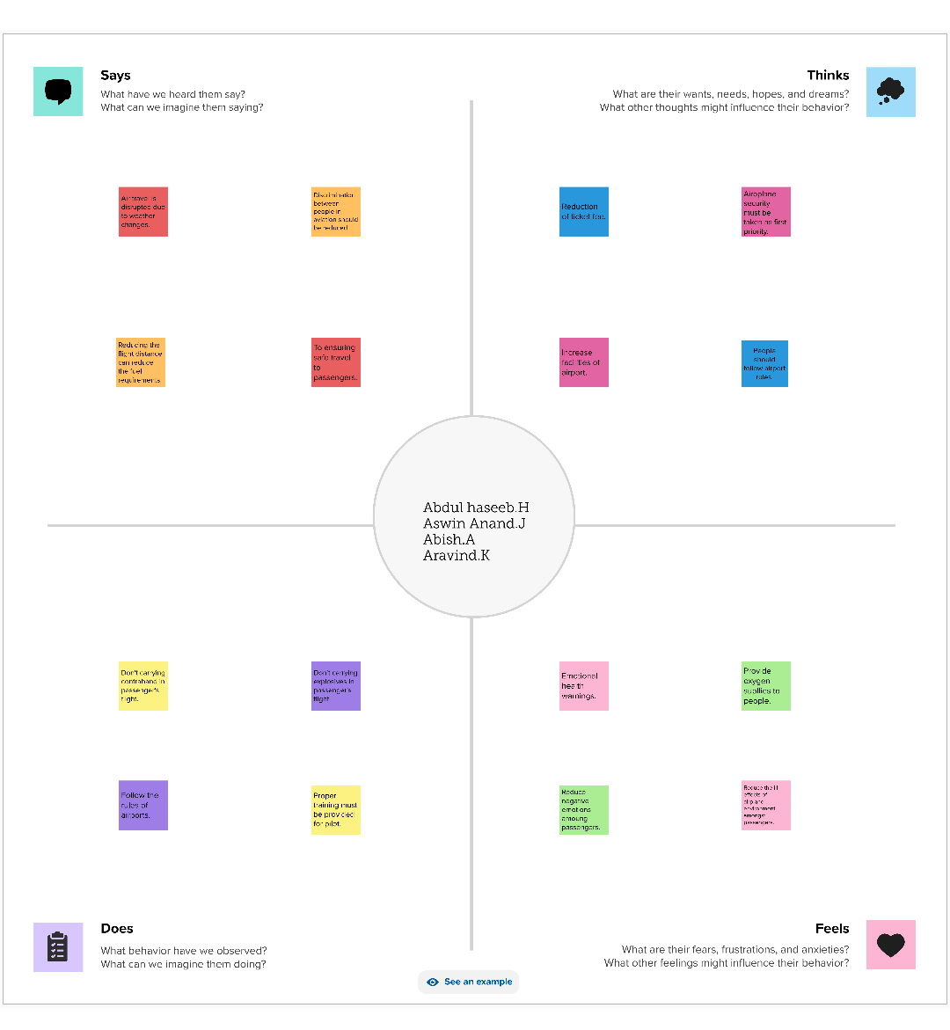

2.2 IDEATION AND BRAINSTROMING MAP

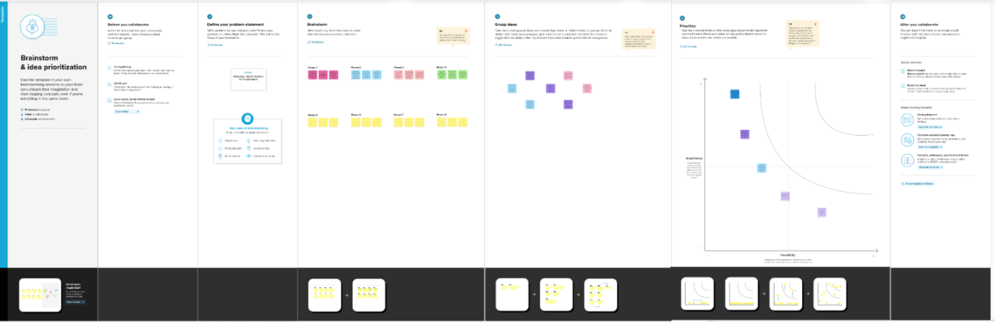

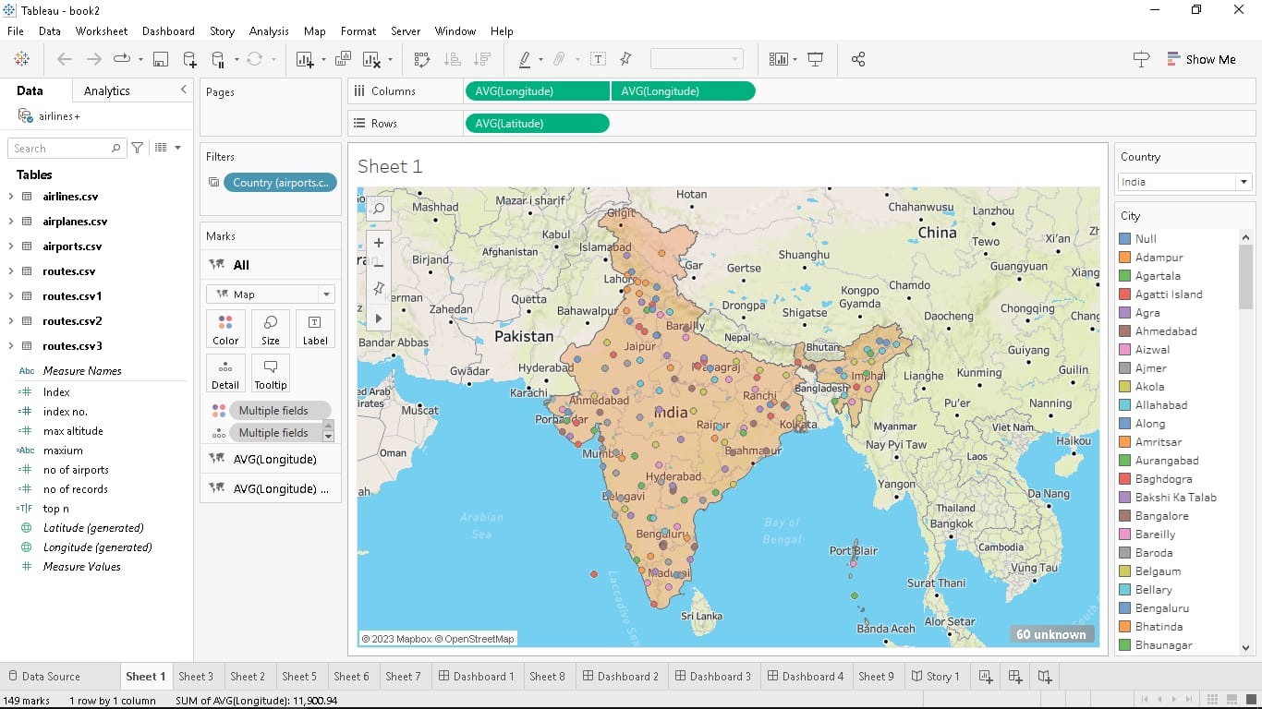







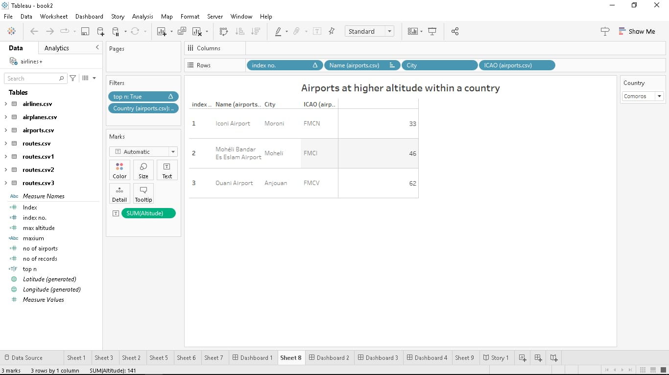

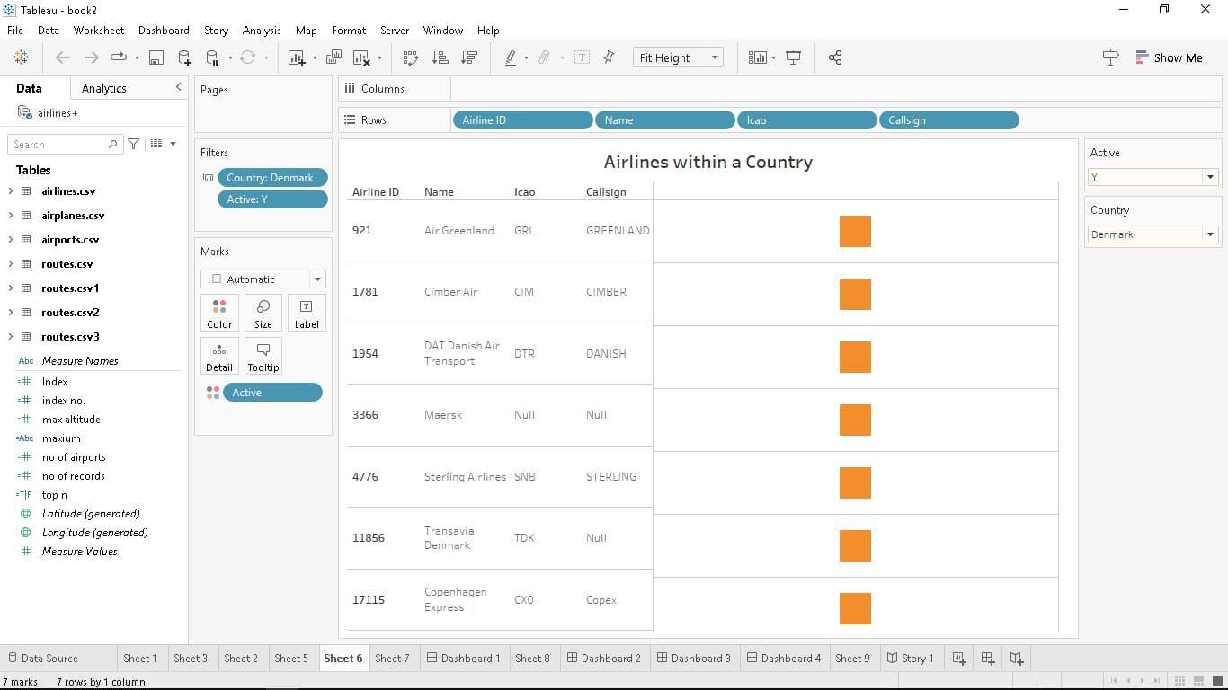





4. ADVANTAGES AND DISVANTAGES

4.1.ADVANTAGES

1. Speed: Air travel is one of the fastest modes of transportation available. It allows people and goods to reach their destinations quickly, which is especially important for time-sensitive shipments, emergency medical cases, and long-distance travel.

2. Global Reach: Air transportation networks connect cities and countries around the world. This extensive network enables global trade, tourism, and the rapid movement of people and goods across borders.

3. Accessibility to Remote Areas: Airports can be established in remote or geographically challenging locations, providing access to areas that may be difficult to reach by other means of transportation. This is particularly valuable for delivering supplies to remote communities or providing medical services to isolated regions.

4. Efficiency: Air travel is highly efficient for long-distance travel. Modern aircraft are designed to carry large numbers of passengers and cargo, reducing the cost per unit transported, and making air transportation an economical option for many purposes.

5. Frequency of Service: Air transportation networks often offer frequent flights between major cities, providing flexibility and convenience for travelers. This frequency is especially important for business travelers and tourists.

6. Connectivity: Airports are typically connected to other modes of transportation, such as buses, trains, and taxis, making it easy for passengers to reach their final destinations. This integrated transportation network simplifies the travel experience.

7. Safety: Commercial aviation is subject to stringent safety regulations and standards. Air travel is generally considered one of the safest modes of transportation, with a low accident rate per passenger-mile.

8. Predictable Schedules: Airlines publish schedules well in advance, allowing passengers to plan their trips with confidence. This predictability is important for business travelers and those with busy schedules.

9. Cargo Transportation: Air transportation networks facilitate the rapid movement of cargo, including perishable goods, pharmaceuticals, and high-value items. Air freight is crucial for global trade and supply chains.

10. Environmental Impact: While air travel does produce emissions, modern aircraft are becoming more fuel-efficient, and airlines are working to reduce their environmental footprint. Advancements in aircraft technology and the use of sustainable aviation fuels are helping to mitigate the industry's environmental impact.

4.2.DISADVANTAGES

1. Environmental Impact: Air travel contributes significantly to greenhouse gas emissions, particularly carbon dioxide. The aviation industry is a major contributor to climate change, and efforts to reduce its environmental impact are ongoing.

2. High Operating Costs: Running and maintaining airports, aircraft, and air traffic control systems can be expensive. These costs can lead to high ticket prices and affect the affordability of air travel for many people.

3. Limited Capacity: Airports can become congested, leading to delays, longer waiting times, and increased stress for passengers. Expanding airport capacity is often costly and can face opposition from local communities due to noise and pollution concerns.

4. Weather Dependence:Air travel is highly weather-dependent. Adverse weather conditions, such as fog, thunderstorms, and snow, can lead to delays and cancellations, impacting both passengers and cargo transport.

5. Security Concerns: Airports and aircraft are vulnerable to security threats, including terrorism and hijacking. Security measures can be intrusive, time-consuming, and costly for both passengers and the aviation industry.

6. Noise Pollution: Airports generate noise pollution, which can disrupt local communities and affect the quality of life for people living nearby. Efforts are made to reduce noise through quieter aircraft and flight path optimization.

7. Limited Accessibility: While airports are present in many regions, they may not be accessible to those in remote areas. People in such areas often need to travel long distances to reach an airport, adding to the overall travel time and cost.

8. Limited Cargo Capacity: Although air transport is efficient for high-value and time-sensitive cargo, it may not be cost-effective for bulk cargo transportation. Ships and trains are more suitable for transporting heavy or large-volume goods.

9. Infrastructure Development: Building and maintaining airports and the associated infrastructure, such as runways and air traffic control systems, requires significant investments. This can strain government budgets and resources.

10. Economic Inequality: The cost of air travel can be prohibitive for many individuals, limiting access to those who can afford it. This can create disparities in access to opportunities and experiences.

5. APPLICATION

1. Passenger Travel: The most common use of air transportation networks is for passenger travel. People use air travel for both domestic and international trips, including business travel, vacations, family visits, and tourism.

2. Business and Trade: Airlines facilitate the movement of business professionals, enabling them to attend meetings, conferences, and trade events. Air cargo services transport goods and products quickly and efficiently, supporting global trade and supply chains.

3. Emergency and Medical Services: Air transportation networks play a crucial role in providing rapid medical services and emergency response. Air ambulances transport critically ill patients to specialized medical facilities, and relief agencies use air cargo to deliver medical supplies and humanitarian aid during emergencies.

4. Tourism: The tourism industry heavily relies on air travel, as it enables people to visit various destinations worldwide. Air transportation networks provide easy access to popular tourist spots and remote destinations.

5. Search and Rescue: Aircraft, including helicopters, are used in search and rescue operations, helping locate and assist people in distress, whether in remote wilderness areas, at sea, or during natural disasters.

6. Military and Defense: Air transportation networks are critical for military operations, enabling the rapid deployment of troops, equipment, and supplies in both peacetime and times of conflict.

7. Agriculture: Agricultural aircraft are used for tasks like crop dusting, pest control, and seeding. These planes support farming and ensure agricultural productivity.

8. Wildlife Conservation: Aircraft are used in wildlife conservation efforts to monitor wildlife populations, track migration patterns, and transport conservationists and researchers to remote areas.

9. Education and Training: Aviation schools and training centers use aircraft in pilot training programs. Flight simulators and practical flight experiences are essential for training future pilots and aviation professionals.

10. Meteorological Research: Aircraft are used to gather data for meteorological research and atmospheric studies. They help improve weather forecasting and our understanding of climate change.

6.CONCLUSION

1. Global Connectivity: Air transportation networks have made the world more interconnected than ever before. They facilitate international trade, tourism, diplomacy, and the exchange of knowledge, culture, and ideas.

2. Efficiency and Speed: The speed of air travel is unmatched, allowing people and goods to move swiftly across great distances. This efficiency is vital for time-sensitive endeavors, from business deals to medical emergencies.

3. Economic Engine: The aviation industry is a significant driver of economic growth, generating employment and stimulating various sectors, including tourism, manufacturing, and technology.

4. Humanitarian Impact: Air transportation plays a vital role in responding to humanitarian crises, enabling the rapid delivery of aid, medical supplies, and emergency personnel to disaster-stricken areas.

5. Environmental Challenges: While offering numerous benefits, air transportation also poses environmental challenges, contributing to greenhouse gas emissions and climate change. Reducing the industry's environmental impact is a critical global concern.

6. Access and Disparities: Despite its advantages, air travel is not equally accessible to all. Economic disparities can limit the opportunities and experiences of those who cannot afford it.

7. Security and Safety: Security remains a top priority, with ongoing efforts to safeguard passengers and cargo from threats and emergencies.

8. Innovation and Sustainability: Advances in technology and the development of sustainable aviation practices are shaping the future of air travel. These innovations aim to increase efficiency, reduce environmental impacts, and improve the overall sustainability of the industry.

9. Resilience in Crises: The global air transportation network has demonstrated its resilience in the face of crises, including pandemics and natural disasters. It plays a crucial role in facilitating responses to such events.

7.FUTURE SCOPE

1. Sustainability and Environmental Concerns: Sustainability will be a central theme in the future of global air transportation. The aviation industry is under increasing pressure to reduce its environmental impact. This will drive innovation in the development of more fuel-efficient aircraft, the use of sustainable aviation fuels, and the exploration of alternative propulsion systems, such as electric and hydrogen-powered planes.

2. Advanced Technologies: Technology will play a pivotal role in enhancing the efficiency and safety of air transportation. Automation, artificial intelligence, and data analytics will optimize air traffic management, reduce delays, and improve safety. The development of supersonic and hypersonic commercial flight may significantly reduce travel times.

3. Urban Air Mobility: Urban air mobility (UAM) is on the horizon, with the potential for electric vertical takeoff and landing (eVTOL) aircraft to offer short-distance, on-demand air travel within cities. UAM has the potential to reduce road congestion and offer more efficient transportation in densely populated areas.

4. Inclusive Access: Efforts will continue to make air travel more accessible to a broader population. This includes initiatives to reduce ticket prices, improve airport infrastructure, and support regional and remote airports to ensure that more people can benefit from air transportation.

5. Changing Market Dynamics: Economic growth in emerging markets will drive increased demand for air travel. Airlines and airports will need to adapt to changing market dynamics, particularly in regions with burgeoning middle-class populations.

6. Global Health Considerations: The COVID-19 pandemic has reshaped the aviation industry. The future of air travel will include a focus on health and safety protocols to mitigate the spread of diseases. Vaccine passports and testing may become more integrated into the travel experience.

7. Security and Data Privacy: Ongoing concerns about security, data privacy, and cyber threats will require the industry to continually enhance its security measures and adapt to new challenges in a digitally connected world.

8. Infrastructure Expansion and Modernization: Airports around the world will require expansion and modernization to accommodate growing demand. Investments in airport infrastructure and technologies will be essential to maintain the efficiency of the global air transportation network.

9. International Cooperation: Global air travel is inherently international. International cooperation and agreements will be necessary to ensure smooth operations, harmonize regulations, and address cross-border challenges such as climate change and security.

10. Resilience in Crisis: The industry will continue to build resilience to handle future crises effectively. The lessons learned from the COVID-19 pandemic will inform strategies for managing and recovering from future disruptions.